# PEER EVALUTION - **BROCHURE**

YOUR NAME: __Voeun Chanthou_____________________________

THE STUDENT YOU ARE EVALUATING: ____Mao Peaktra__________________________

To submit:

* + You will need to **analyse 1 brochure**
  + **Please include the brochure in this doc**
  + Complete this document
  + Submit you work on Google classroom

**BROCHURE**

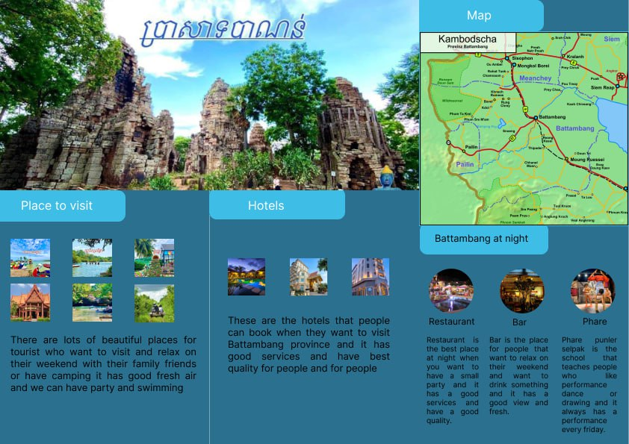

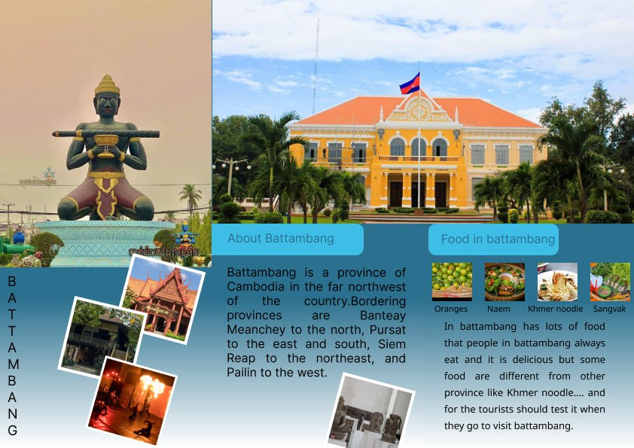

**EVALAUTION GRID**

|  |  |  |
| --- | --- | --- |
| CATEGORY | CRITERIA | EXAMPLE OF ANALYSIS |
| **FONT** | The **fonts**, the **font size**, and style are well selected and create a visual **interest** | Fonts is good. Because She use a font in brochure. And Font size not good and font color the same.  You should use font size the same is better. |
| **COLOR** | The **color palette** is well selected and create a visual **interest** | For page is good, but page is not so good. Because page has one color is blue. And we can’t easy to watch.    You should improve color in page 2. |
| **COMPOSITION** | The layout of the design well-organized and **easy to follow**, with a clear **hierarchy** of information | The layout of the design well and easy to follow, with a clear information. We know about start and the end. |
| **CONTRAST** | Is there sufficient **contrast** between the different elements of the design to **make them stand out** and create visual interest | Contrast on stly of title(Battambong) and Contrast color main point. But you should edit where you think is important. |
| **BALANCE** | Is the design **balanced** in terms of its use of space, text, and graphics | The design balanced in brochure is good. Because it has space, text and graphics. |
| **PROXIMITY** | Are related elements of the design **grouped** together to create **visual unity** and **hierarchy** | The design​​ there are grouped together. But the text has a little mistake. |
| **REPETITION** | Is there consistent use of design elements (such as fonts, colors, and graphics) throughout the design to **create visual unity** | For repetition: frist, repeat on font color, but main point not repeat. Second, repeat on alignment. For alignment she use align center.  And third, repeat on picture. Because all page is always have picture |
| **WHITE SPACE** | Is there sufficient white space (or negative space) in the design to create **visual breathing room** and balance | *White space is good, but you should improve white space in page2​(the last main point) Because places will not be equal* |

**FINAL ANALYSIS**

What are the **good points** of this design? (*Details as much as possible)*

The good points of this design:

* Font : Because she doesn’t use font more than one.
* Text color : Text color always black. It’s so clear.
* Align is very good: She use only one align center.
* Group elements: easy to follow.

What could be **improved**? *(Details as much as possible)*

Could be improved:

* Improve margins: Because it is not equal yet.
* Background color: You should make it repeat between page and page.
* Color main point: Because the last main point isn’t related.